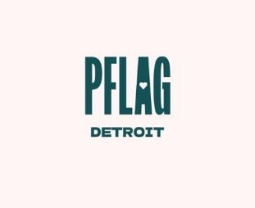

June

2023

PFLAG Detroit

Support
□
Education
□
Advocacy

PFLAG is the extend-
ed family of the
LGBTQ+ community.
We are made up of
LGBTQ+ individuals,
family members and
allies. Because to-
gether, we are strong-
er.

Where We
Meet ...

Lutheran

Church of
the Master

3333
Coolidge Hwy,
Troy, MI 48084

(
Behind Somerset
Mall)

Second Sunday of
each month
(
excluding Mother
’
s
Day, Easter, PRIDE-
and Christmas)

Mailing Address:

PFLAG Detroit

PO Box 1169

Royal Oak MI

48068
-
1169

board@pflagdetroit.org

Join us!

Sunday, June 11th

Corktown Health Center

Mike Flores (He/Him)

Corktown Health Center (corktownhealth.org) is an LGBTQ focused primary care center.

Our speaker, Mike Flores (He/Him), serves as its Vice President of Finance & Strategy. He joined Corktown Health Center in 2019 with more than 15 years of finance, program management, and strategy development experience from the automotive and aerospace industry.

Mike will continue to leverage his experience as the organization grows to new locations and expands current services. Mike holds a BA from the University of Detroit Mercy, and an MBA from Oakland University.

He is passionate about representation at all levels.

As we celebrate our 35th year, est. April 1987, we invite you to join us once again with a renewal of your membership. Those of you who are current members, we thank you for your contribution and support.
Your contribution, at whatever level, will help us continue to offer support, education, and advocacy to LGBT persons, their families, and friends. What does joining the chapter or renewing your membership do for you? It makes you a vital part of PFLAG’s continuing effort to provide support to, education about, and advocacy on behalf of LGBT individuals, their families, and friends.
What does your dues payment do for the chapter? It helps us maintain a stable financial base so that the board of directors can focus on responding to community needs, it pays the bills for the helpline, publications, program costs, and much more. The larger our membership, the more credibility PFLAG has in the community and the more able the chapter is to take on additional projects.
Does all your membership payment stay with this chapter? Most of it does, however $15 is sent annually to PFLAG National to support their organizing and educational efforts on a nationwide scale. (If you asked us NOT to send annual dues to PFLAG National previously, WE WILL NOT) As a national member, you receive their quarterly publication, The PFLAGpole. You can also sign up to receive e-News and get more frequent updates about matters of importance to PFLAG and the LGBT community.
Is your membership donation tax-deductible? Yes! Once you donate, we will provide you documentation necessary for your IRS returns. Make checks payable to PFLAG Detroit and mail your membership to PFLAG Detroit, PO Box 1169, Royal Oak, MI 48068-1169
$35.00 Individual
$45.00 Household
$55.00 Supporting
$105.00 Contributing
$1000.00 Lifetime
Donation of Support
Support can take many forms. In addition to financial support, we have volunteer opportunities that you could consider. For more information on our volunteer needs, please contact me by e-mail at larry@pflagdetroit.org
We look forward to hearing from you.
Best regards,
Larry Jack, President
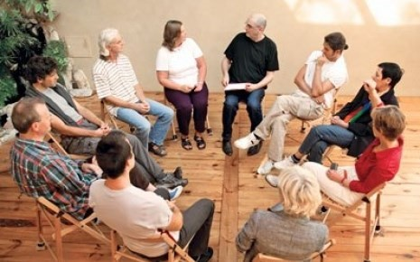
OUR MEETINGS…
As always, we welcome everyone, whether member or non-member and all LGBTQ+ folks, family, friends, and allies.
Our meeting will begin promptly at 2:00 p.m. with introductions, speakers, and followed by support groups. (Support Groups: New Parents, Parents of Transgender,
Transgender, and General Support)
Due to the importance of the stories being told by people in the group discussion, interruptions can be very distracting. We ask that you arrive on time to be able to enter these groups. Any person arriving late, may be asked to form their own group with a PFLAG greeter or Board Member. We appreciate your understanding in this matter.
Our speaker will present at 2:00 p.m. after brief announcements.

